**Cairo University**

**Faculty of Computers and Artificial Intelligence** 

**Data Warehouse Project**

**Phase 1: Proposal and Dimensional Model**

**TA: Alaa Adel**

|  |  |
| --- | --- |
| Name | ID |
| Nadeen Ahmed Byome | 20200581 |
| Asmaa Omar Refaat | 20201019 |
| Toka Ashraf Sayed | 20200121 |
| Rana Mahmoud Mohamed | 20201070 |
| Safa Mahmoud Dosoky | 20201103 |

**2.Source ERD:**

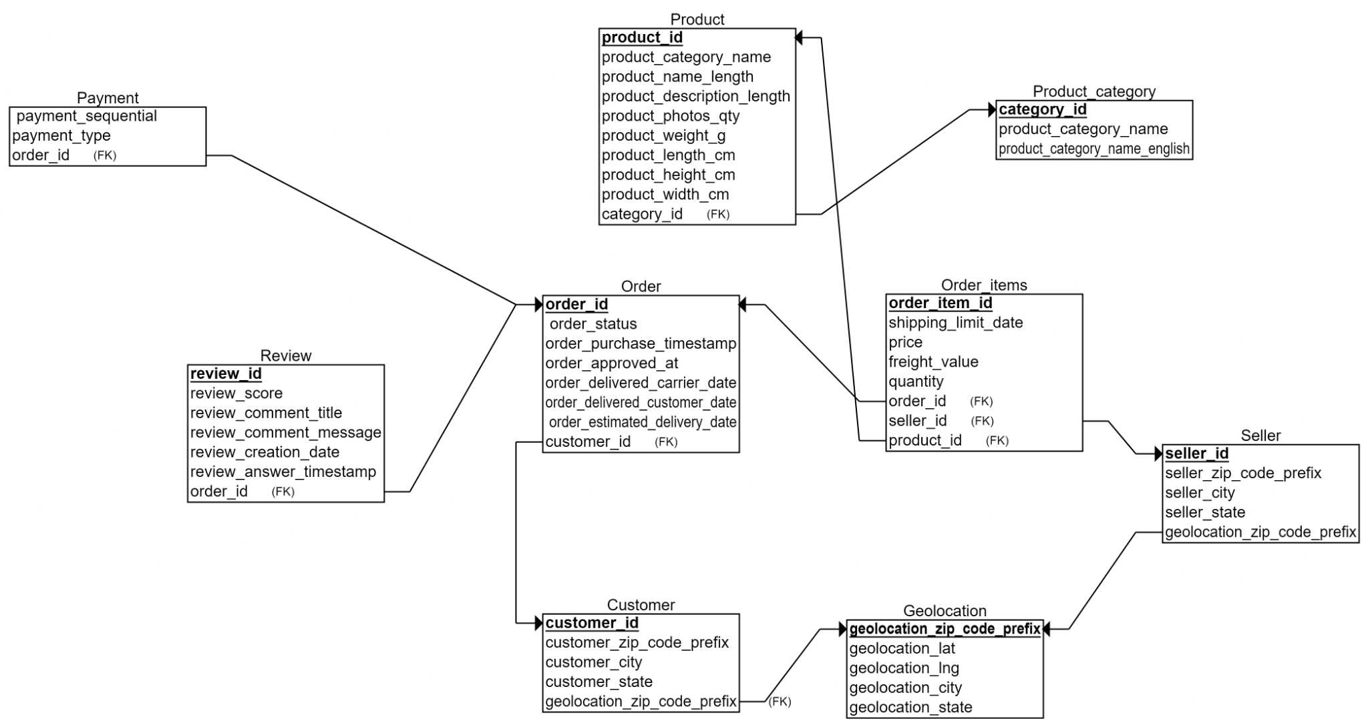

**3.a.Define the business process(es) that you will model:**

Olist E-Commerce store

**3.b.Declare the grain of each fact table (Simply, describe what a fact table record represents):**

1- **Item Fact Table:** numbers of orders in each state.

2- **revenue Fact Table:** Total revenue of each item order.

3- **Review Fact Table:** Number of reviews by a customer

**3.C.Define the dimensions:**

1. **Customer dimension:** This dimension contains information about each customer, such as customer ID, city, state, and zip code.
2. **Product dimension:** This dimension contains information about each product, such as product ID, name, category, and weight.
3. **Time dimension:** This dimension contains information about each date in the dataset, such as day, month, and year.
4. **Order dimension:** This dimension contains information about each order, such as order ID, order status, and delivery date.
5. **Order item dimension:** This dimension contains information about each item, such as price, order item id, freight value.
6. **Review dimension:** This dimension contains information about each review, such as review ID, review score, review comment, and review date.

**3.d. Define the measures that will appear in the fact tables:**

**1.revenue _fact_table:**

* **Total revenue**: This measure calculates the number of total revenues of each item simply it calculates it by multiplying price of each item by the freight value of the item in the last year, and it is a Fully Additive Measure.

**2.Item_fact_table**

* **Numbers of orders**: This measure calculates the numbers of orders in each state, and it is a Fully Additive Measure.

**3.review _fact_table**

* **Number_of_reviews**: This measure calculates the number of reviews by customer, and it is a Fully Additive Measure.

**3.e.Add a diagram of your model:**

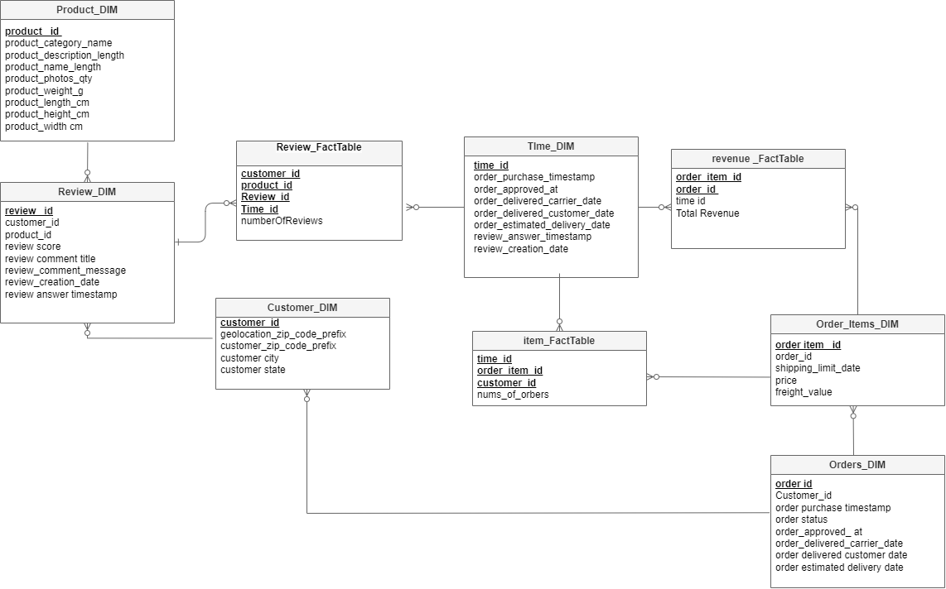

____________________________________________________________________________

**Phase 2**

**Queries**

**Order item fact table**

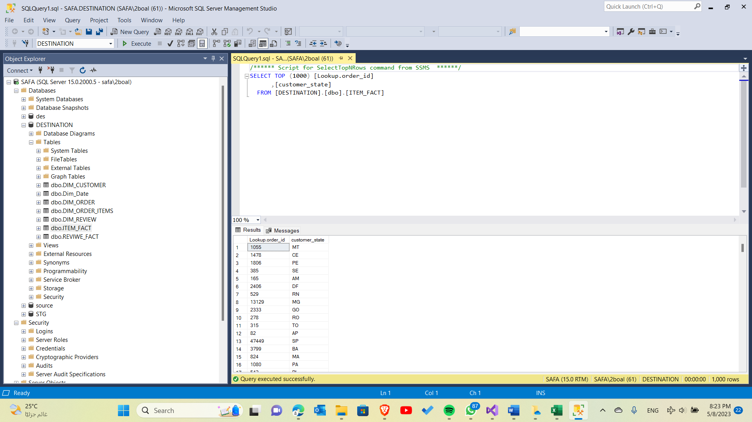

**Review fact table**

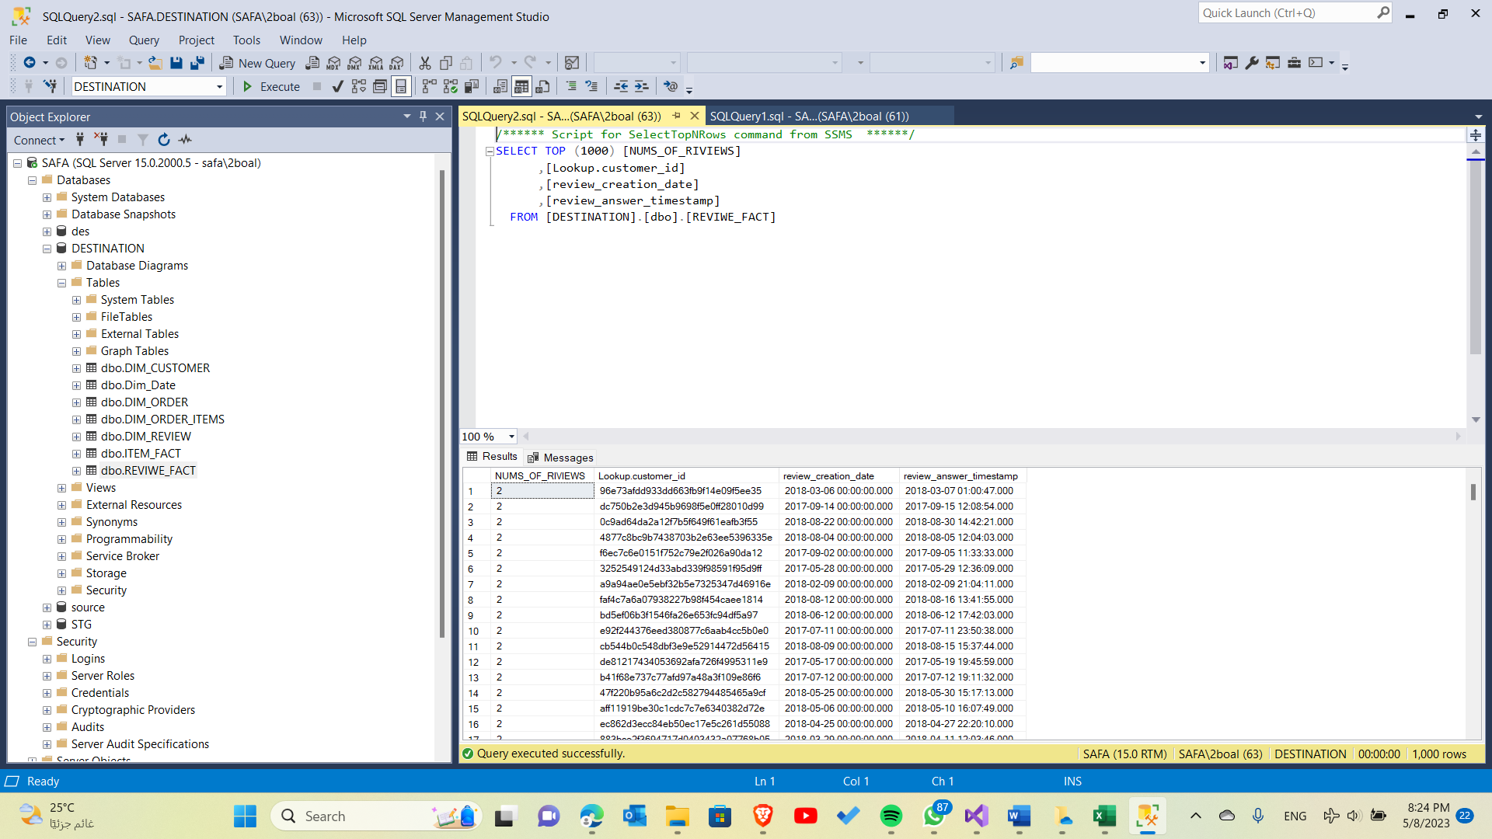

**Revenue fact table**

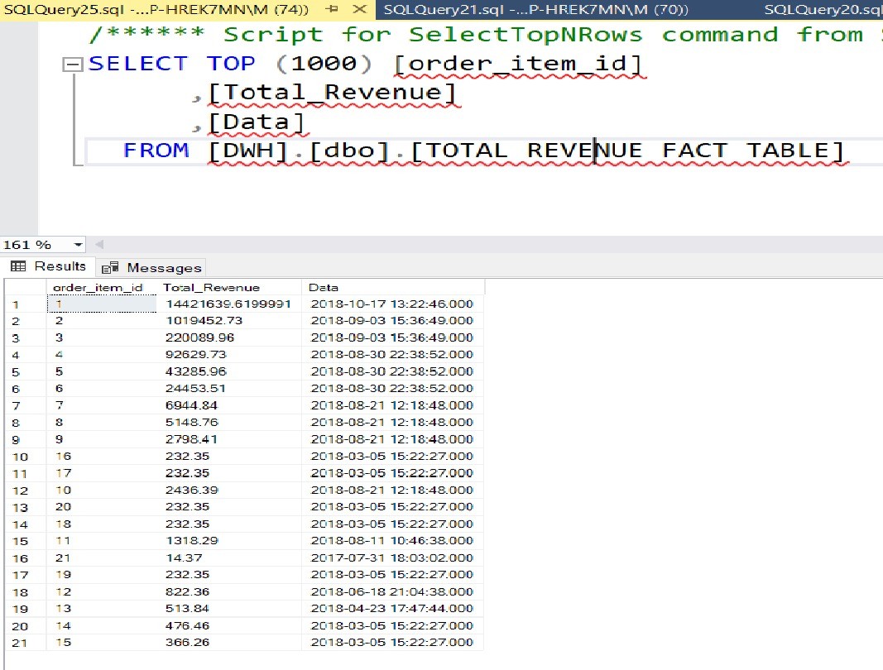

**________________________________________________**

**Deployment**

**Order item fact table**

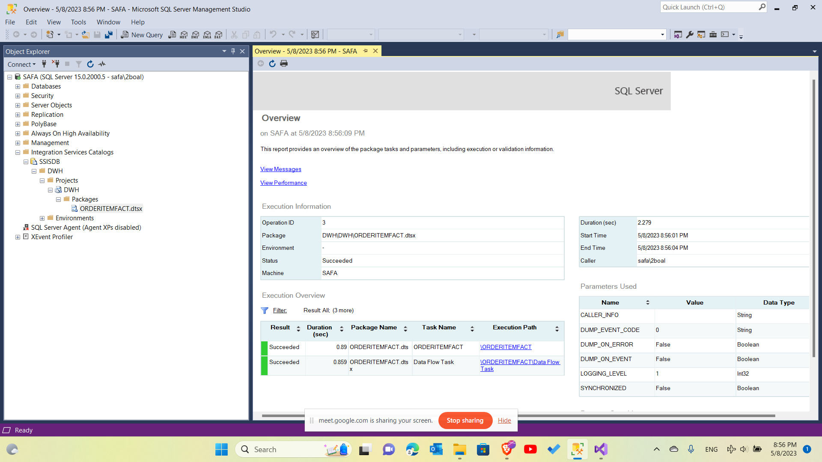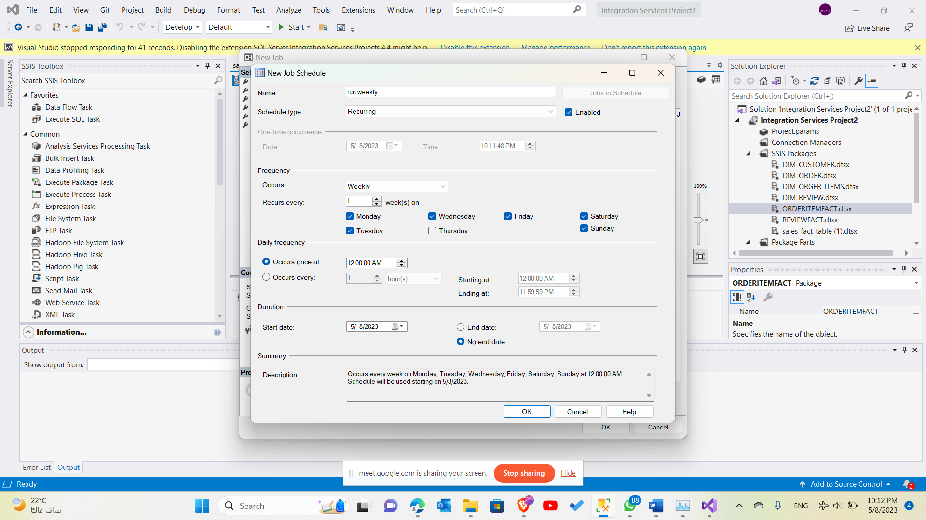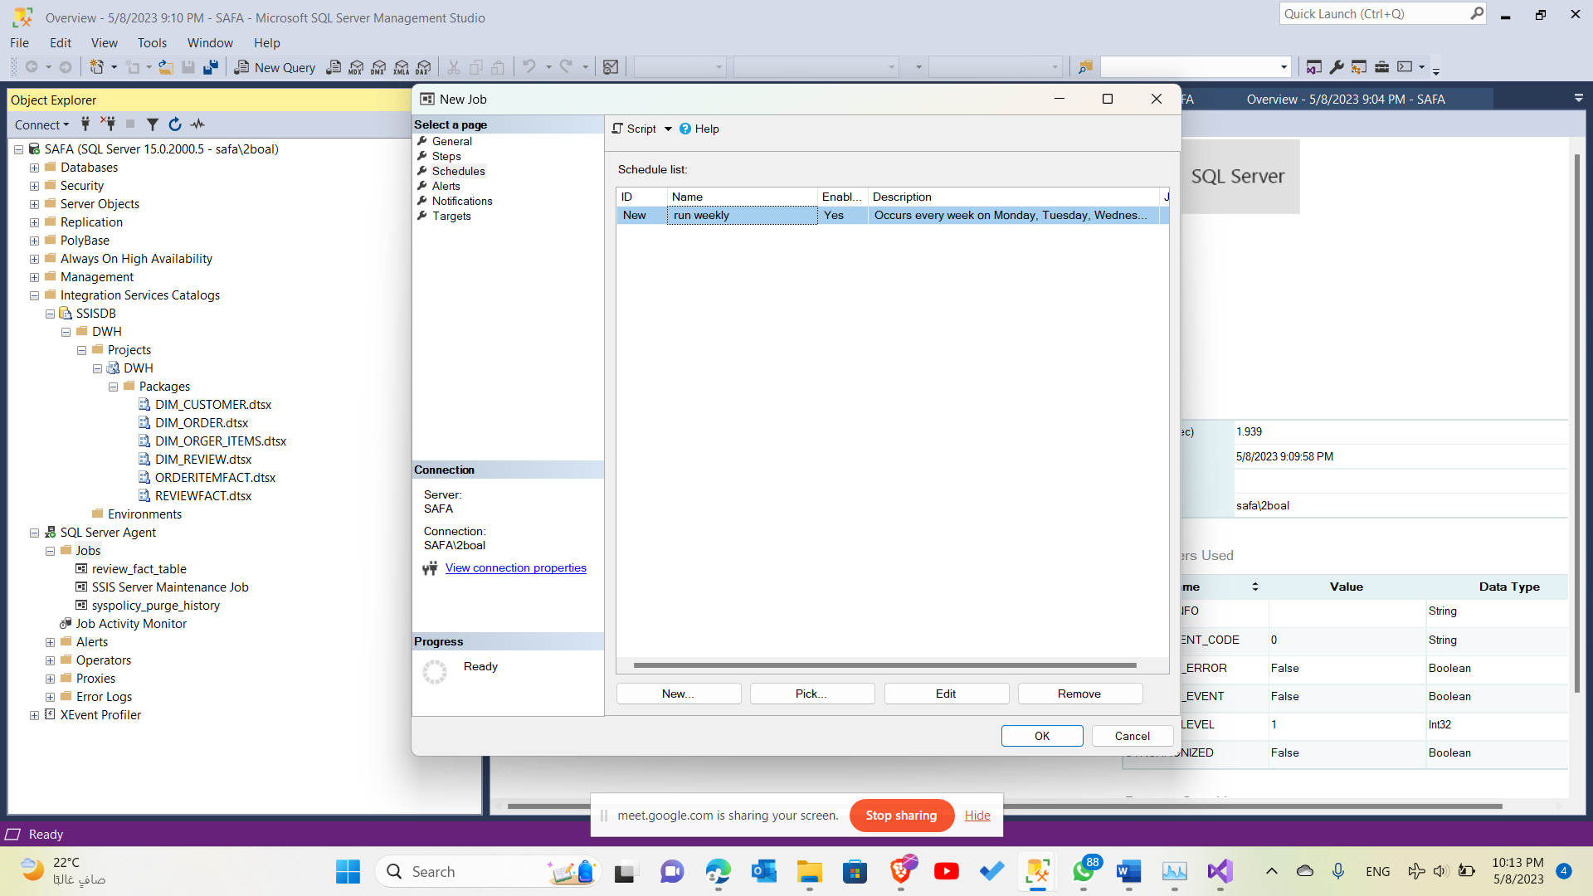

**Review fact table**

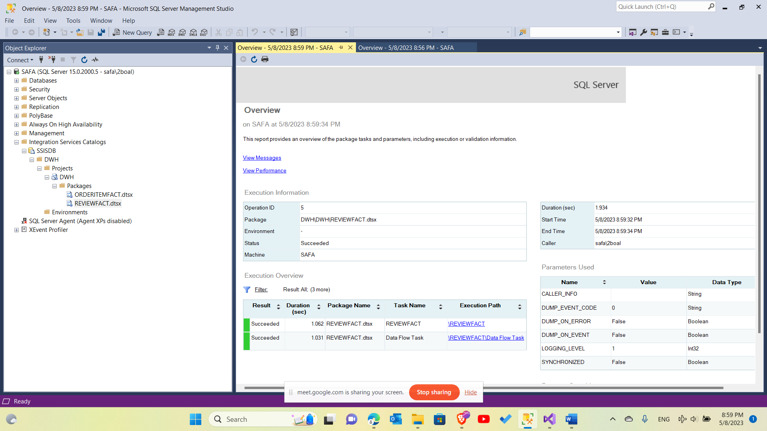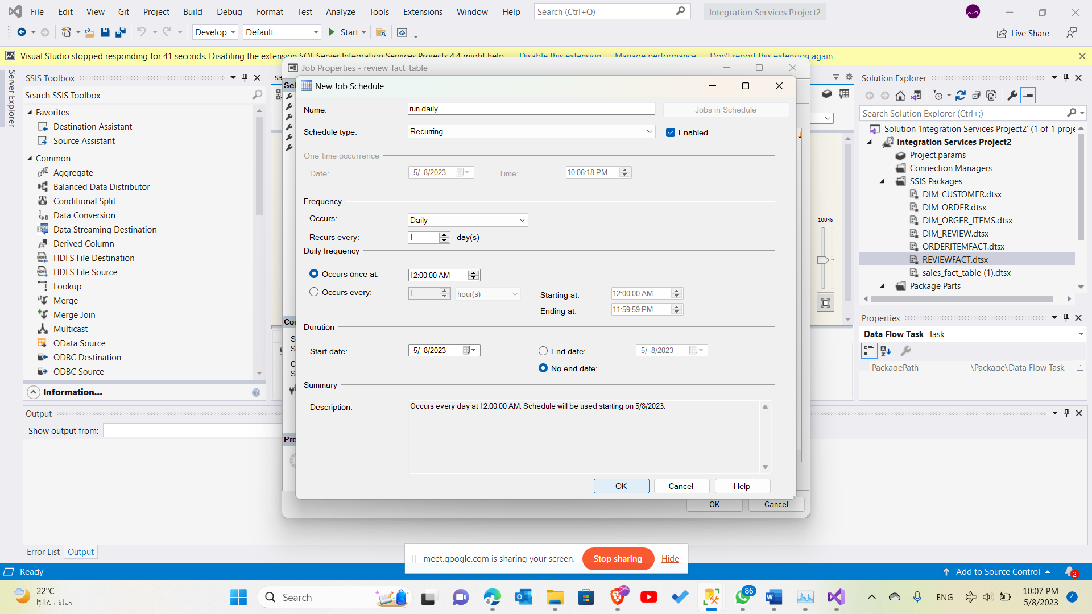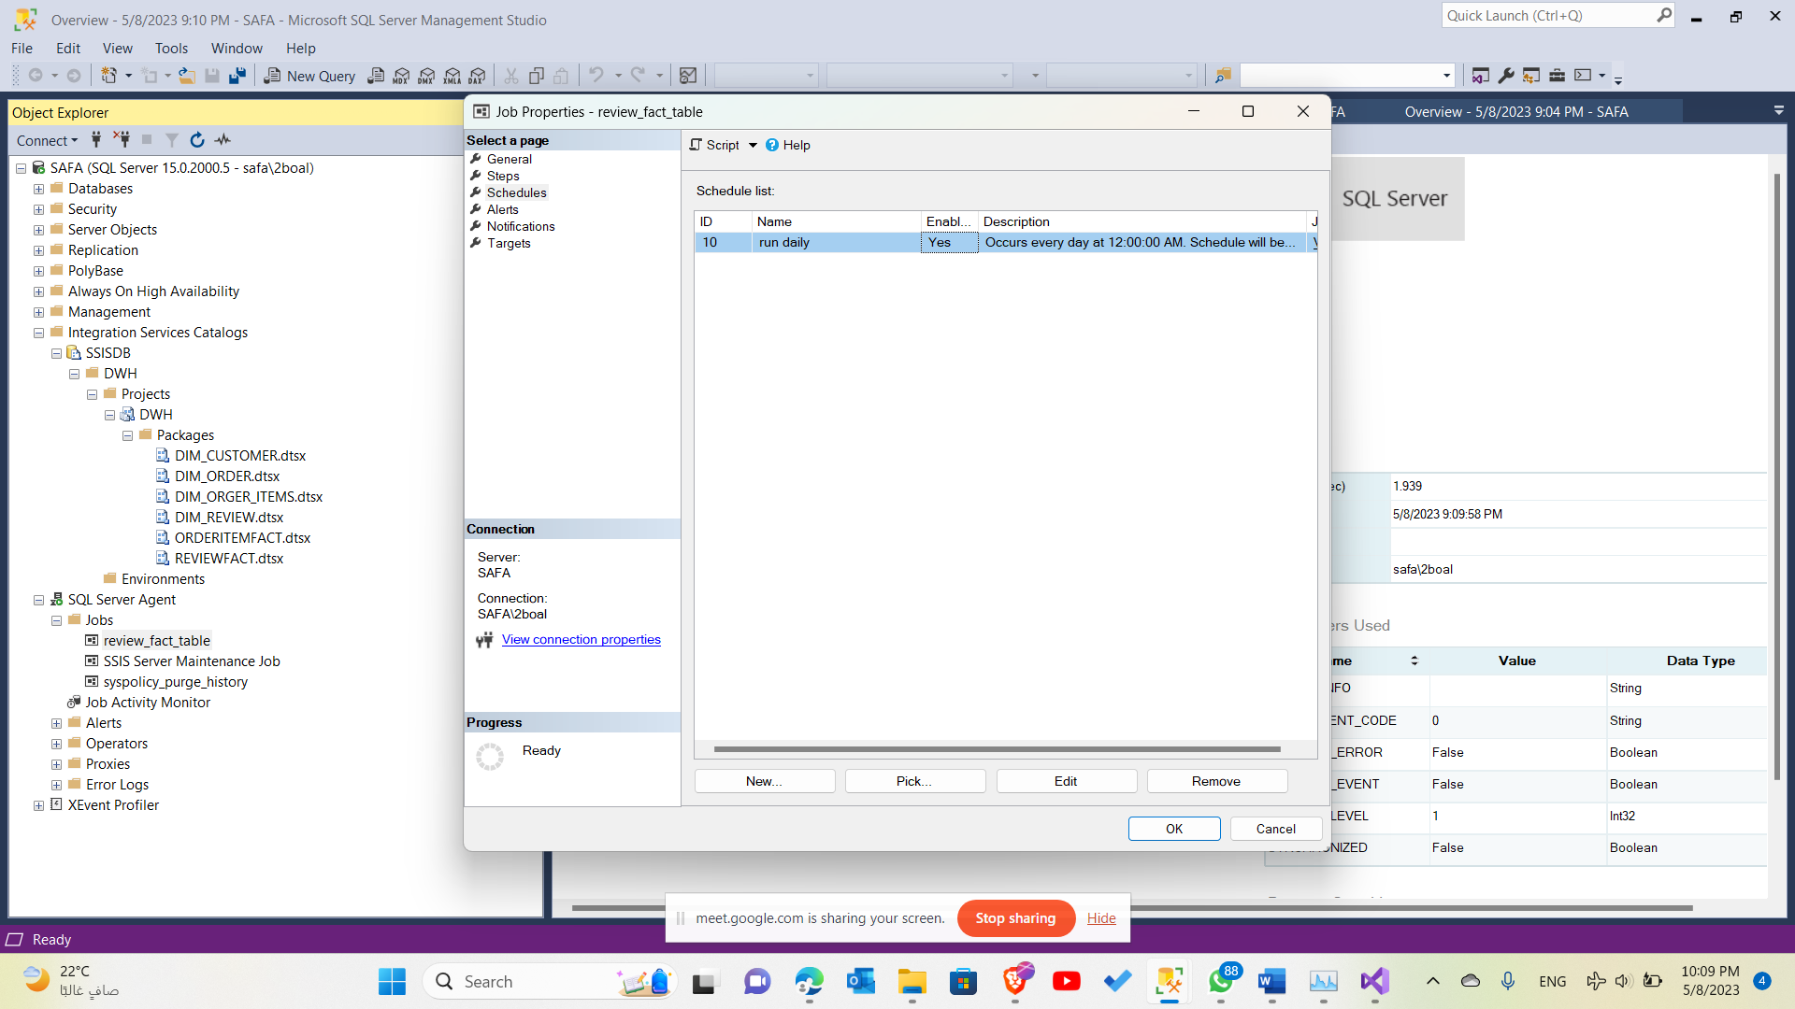

**Revenue fact table**

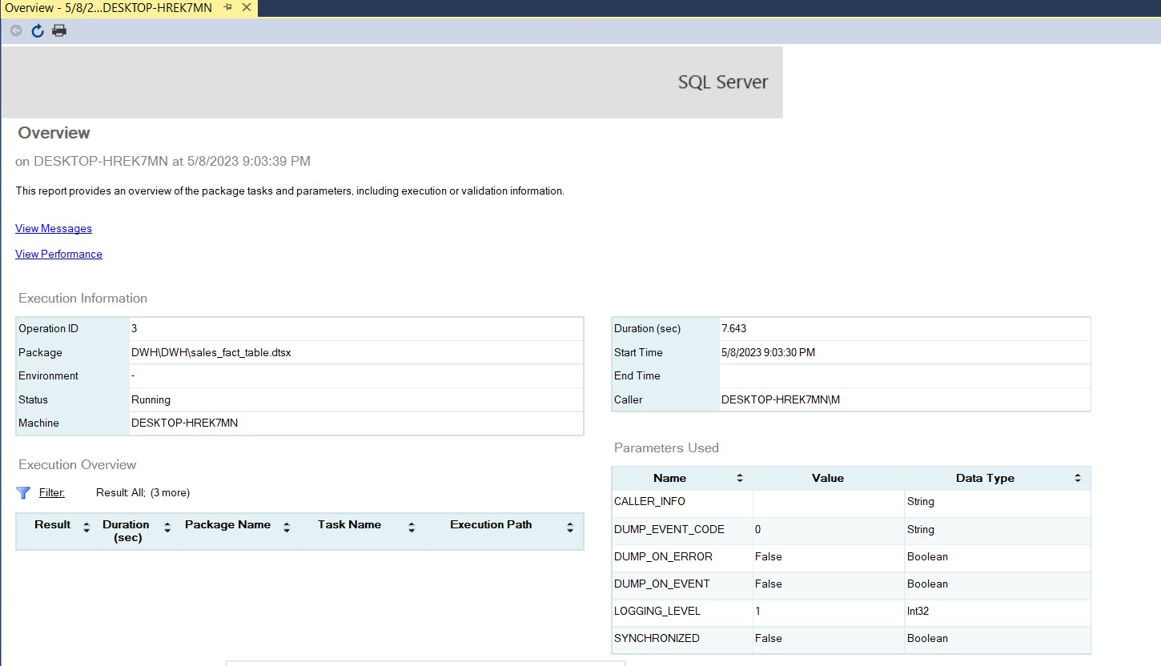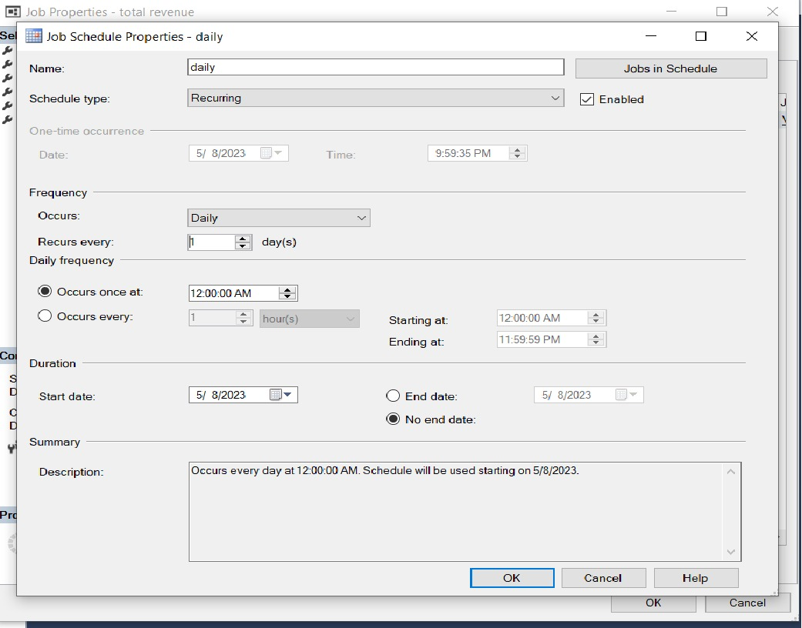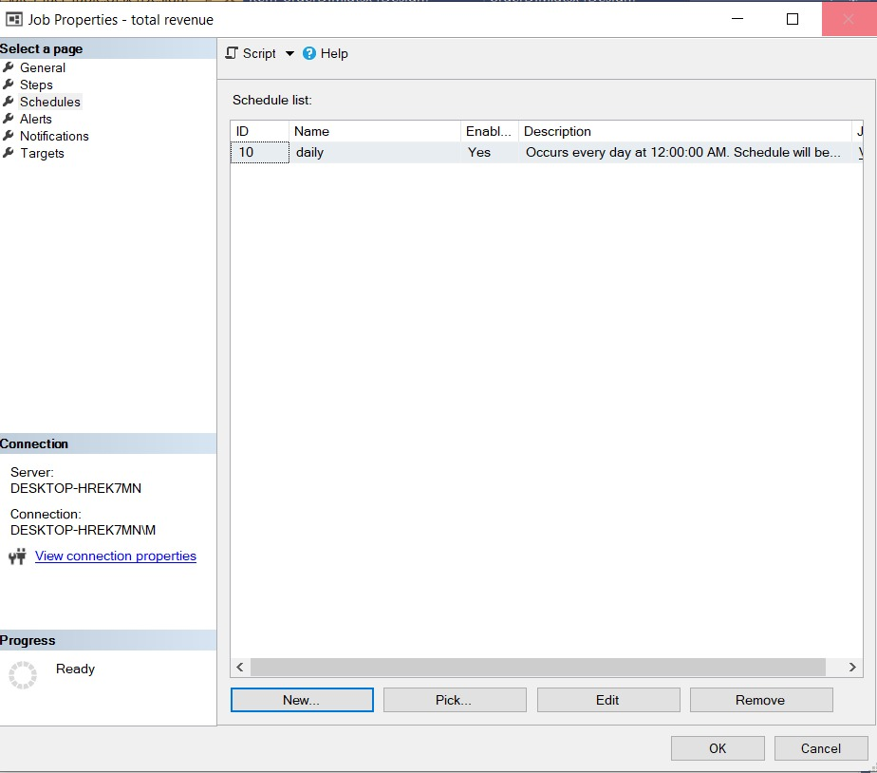

**Cutomer dimension**

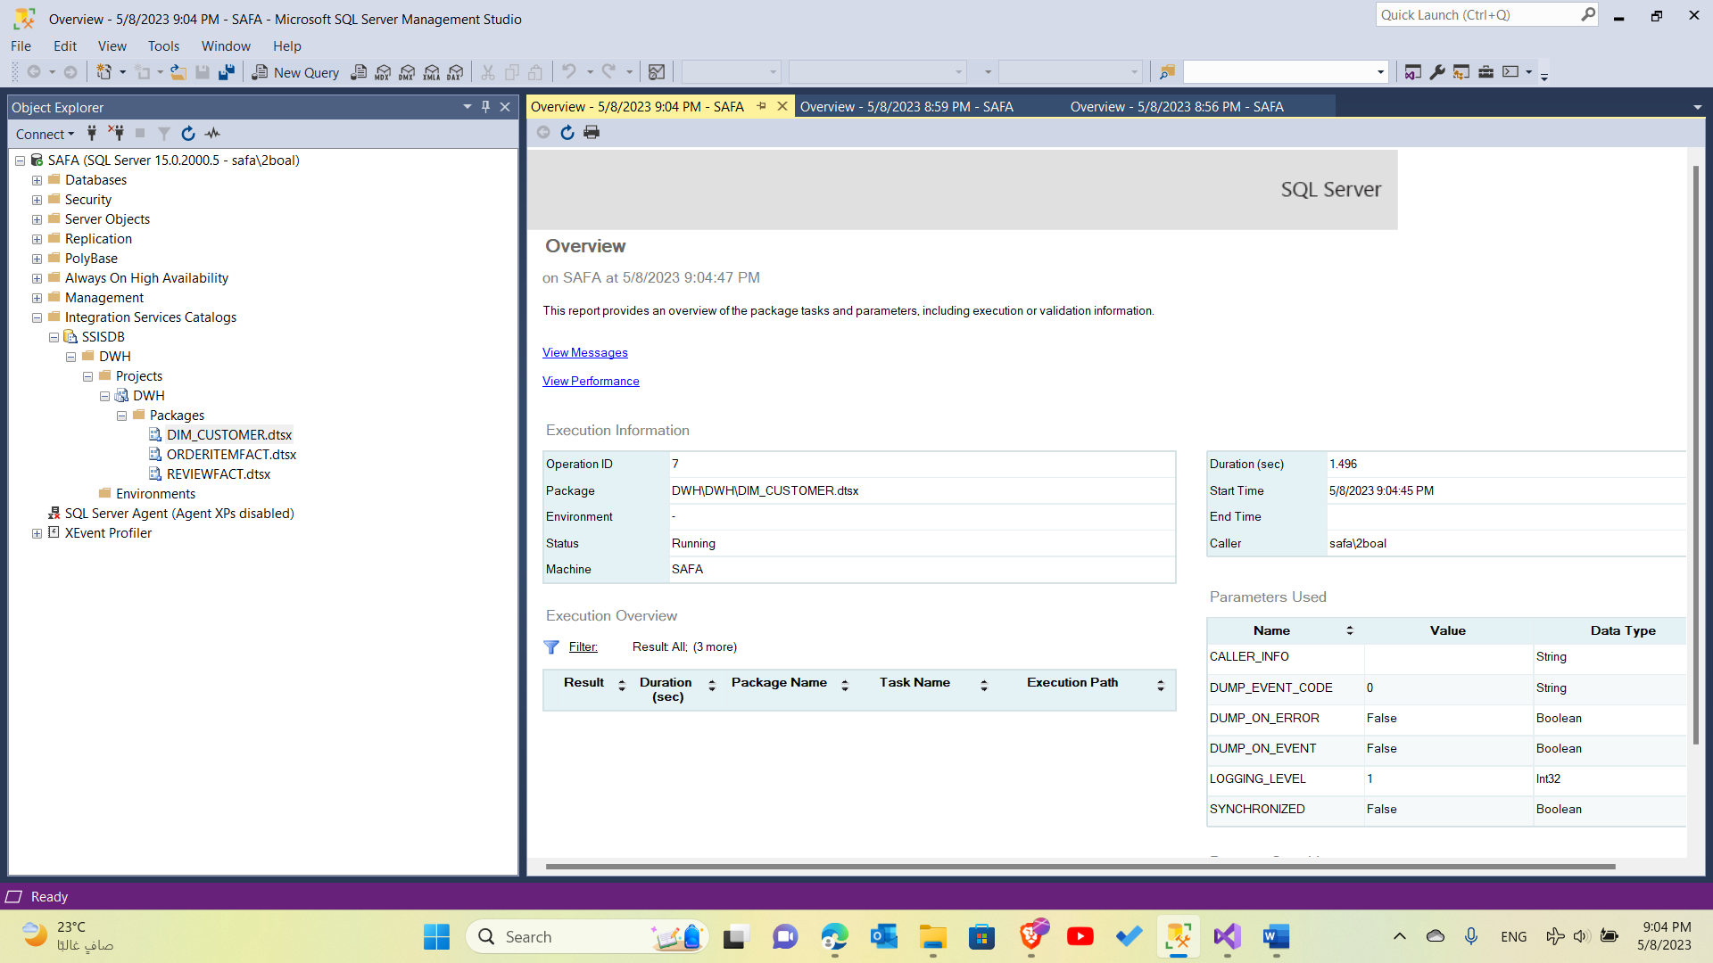

**Order dimension**

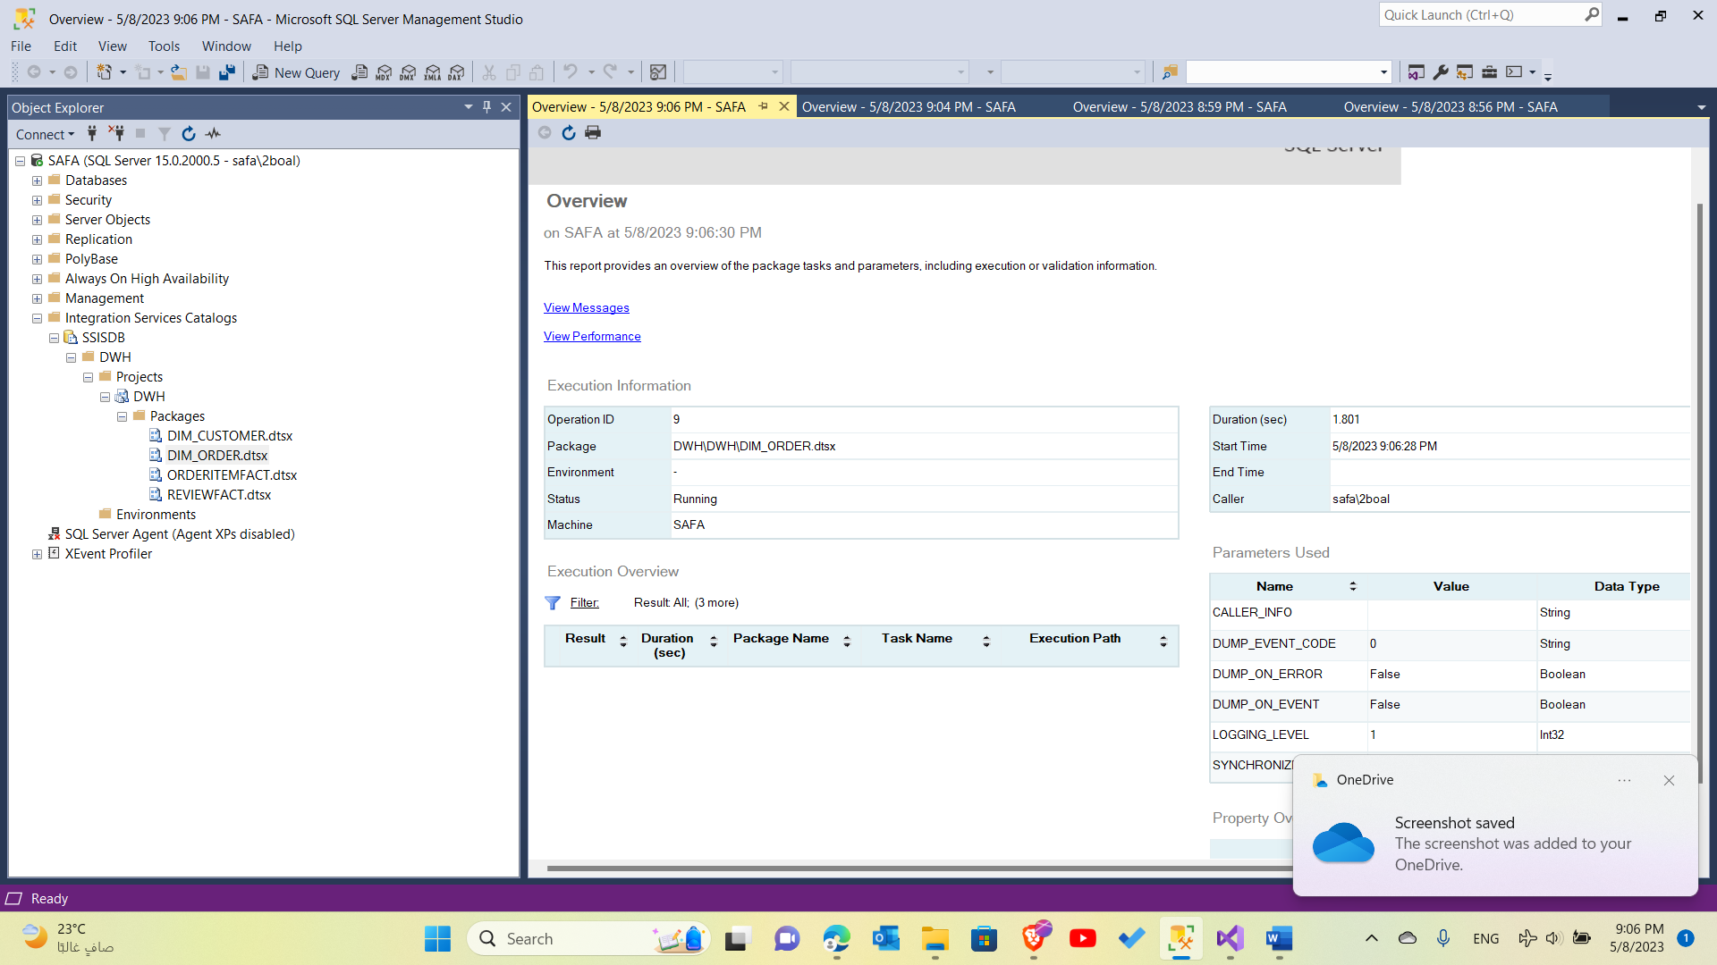

**Order item dimension**

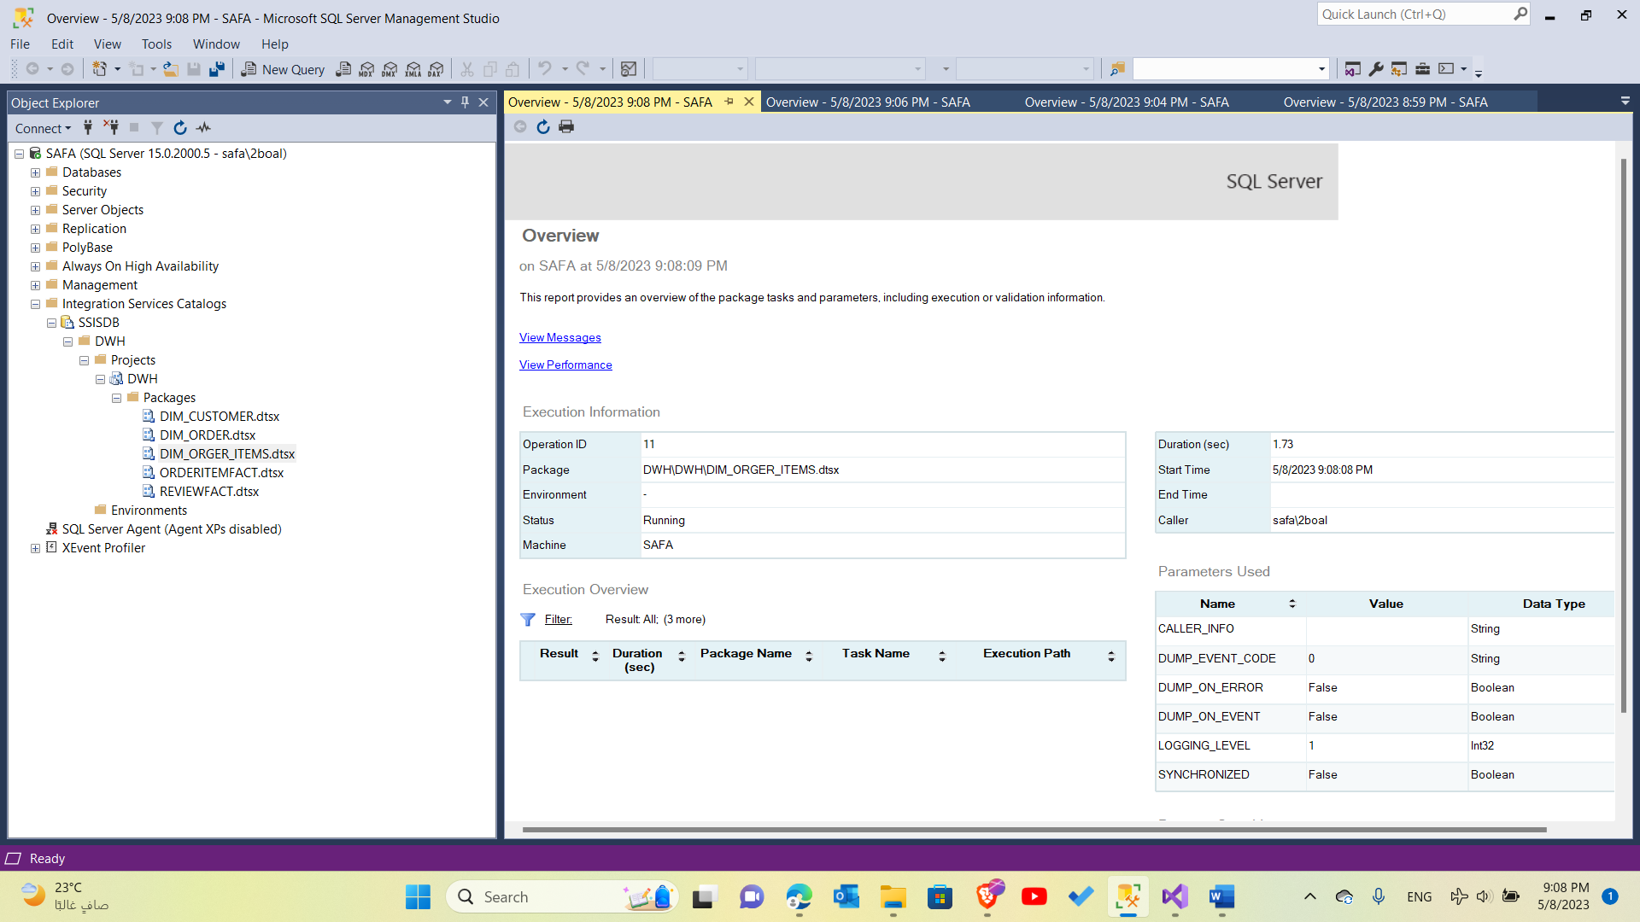

**Review dimension**

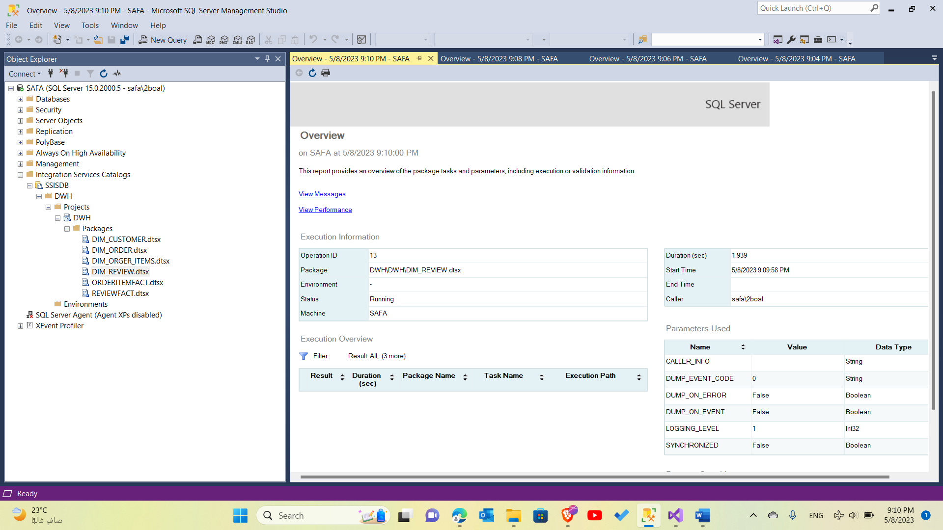

**Product dimension**

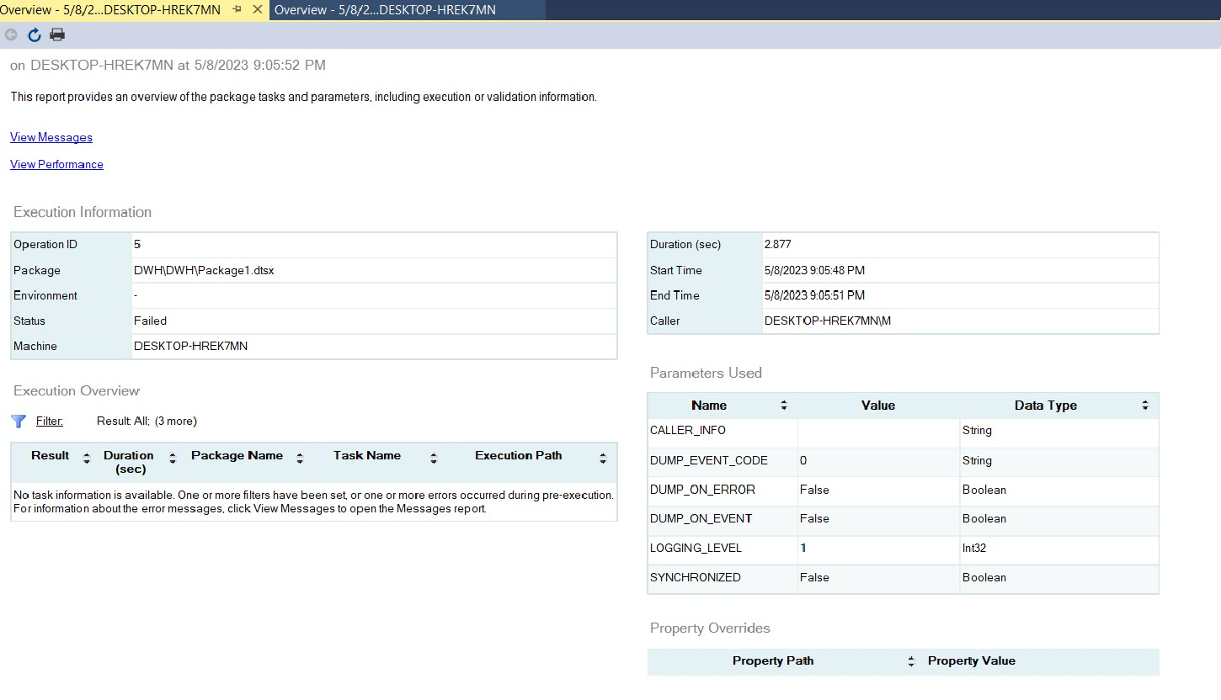

**____________________**

**Fact tables**

**Item fact table**

**Item fact table control flow:**

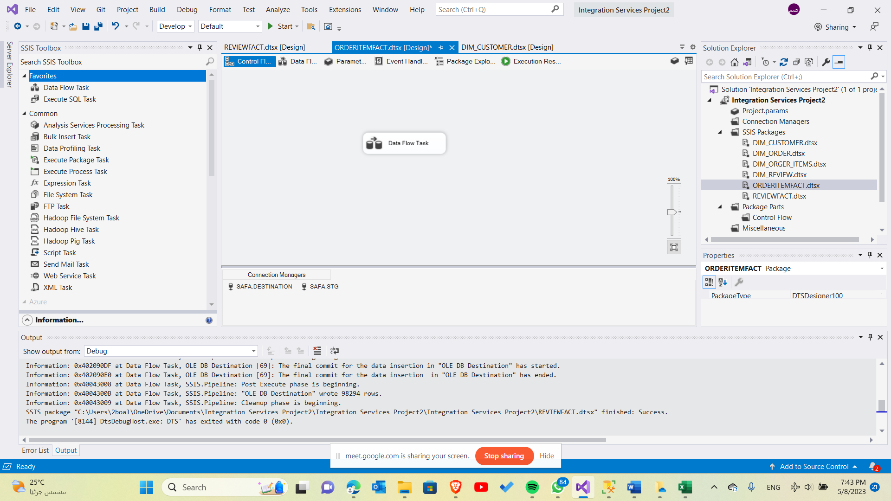

**item fact table data folw:**

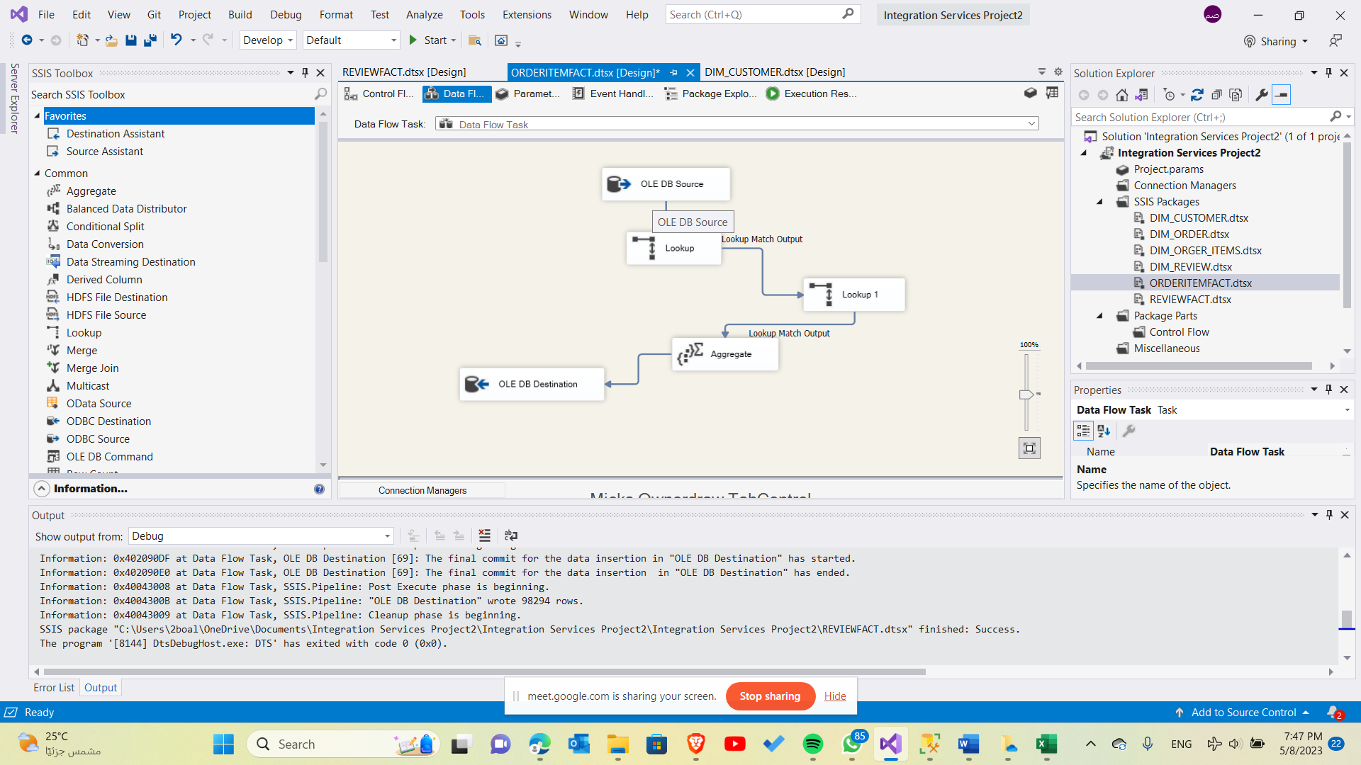

**Review fact table**

**Review fact table control flow:**

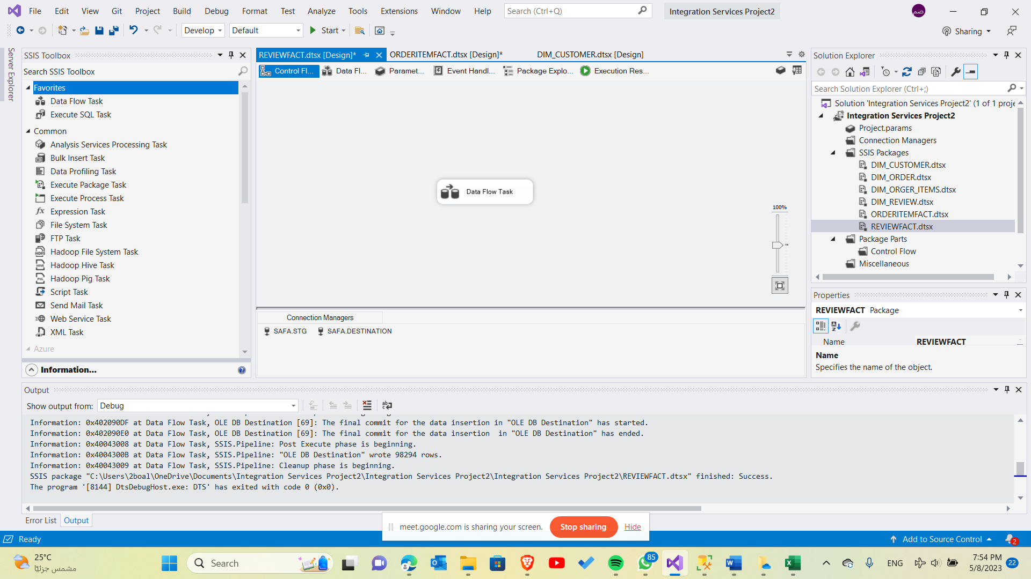

**Review fact table data flow:**

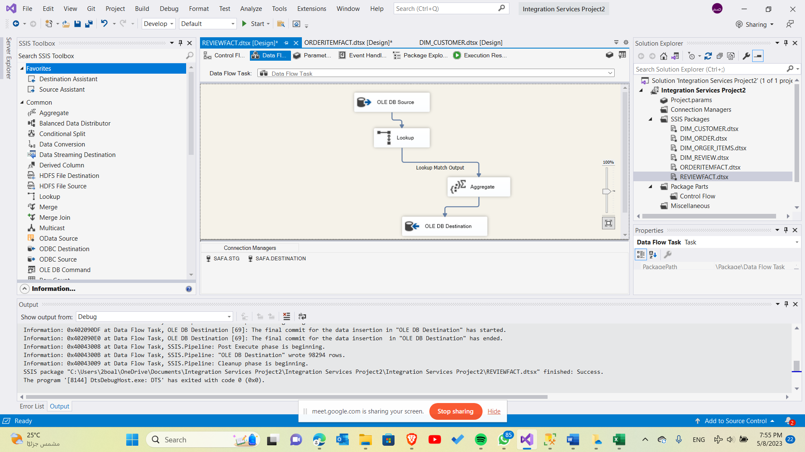

**Revenue fact table**

**Revenue fact table control flow:**

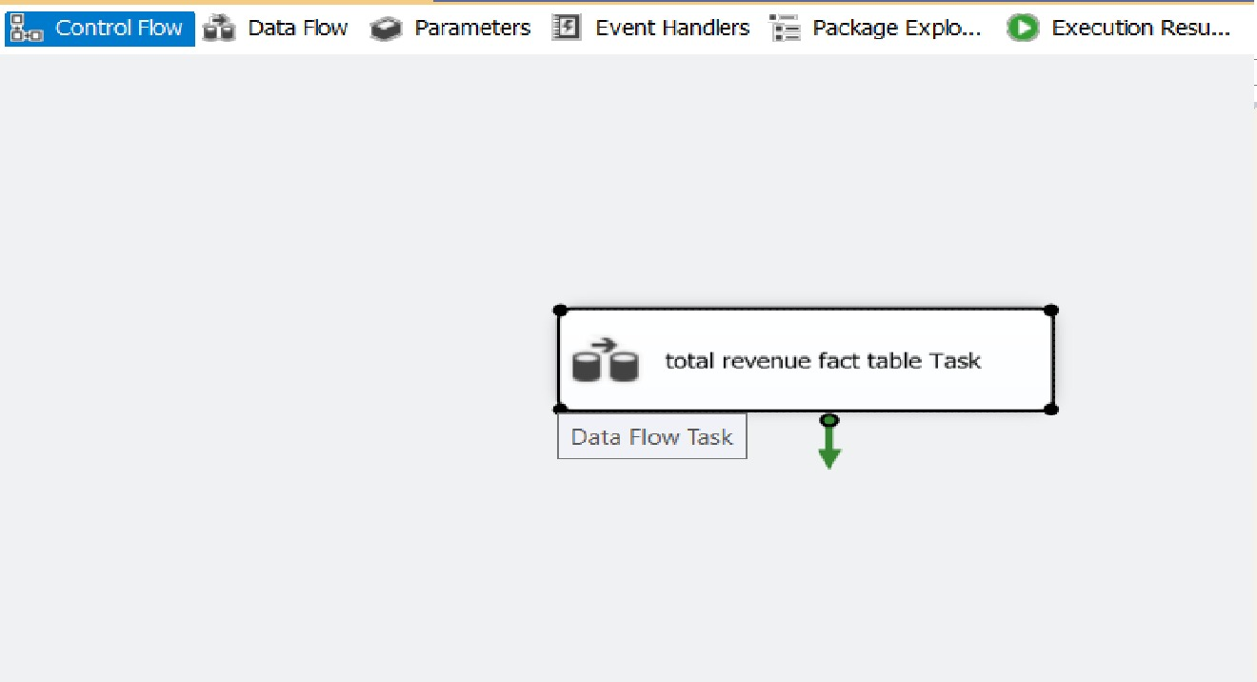

**Revenue fact table data flow:**

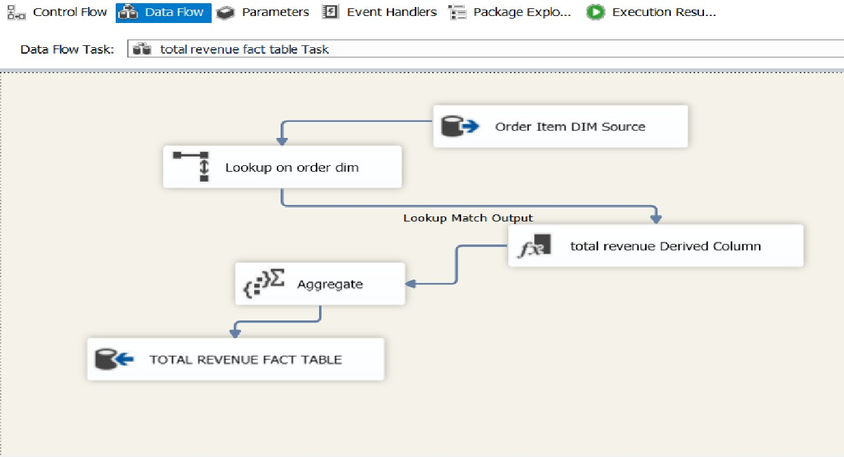

**Dimensions**

**Customer dimension**

**Customer dim control flow:**

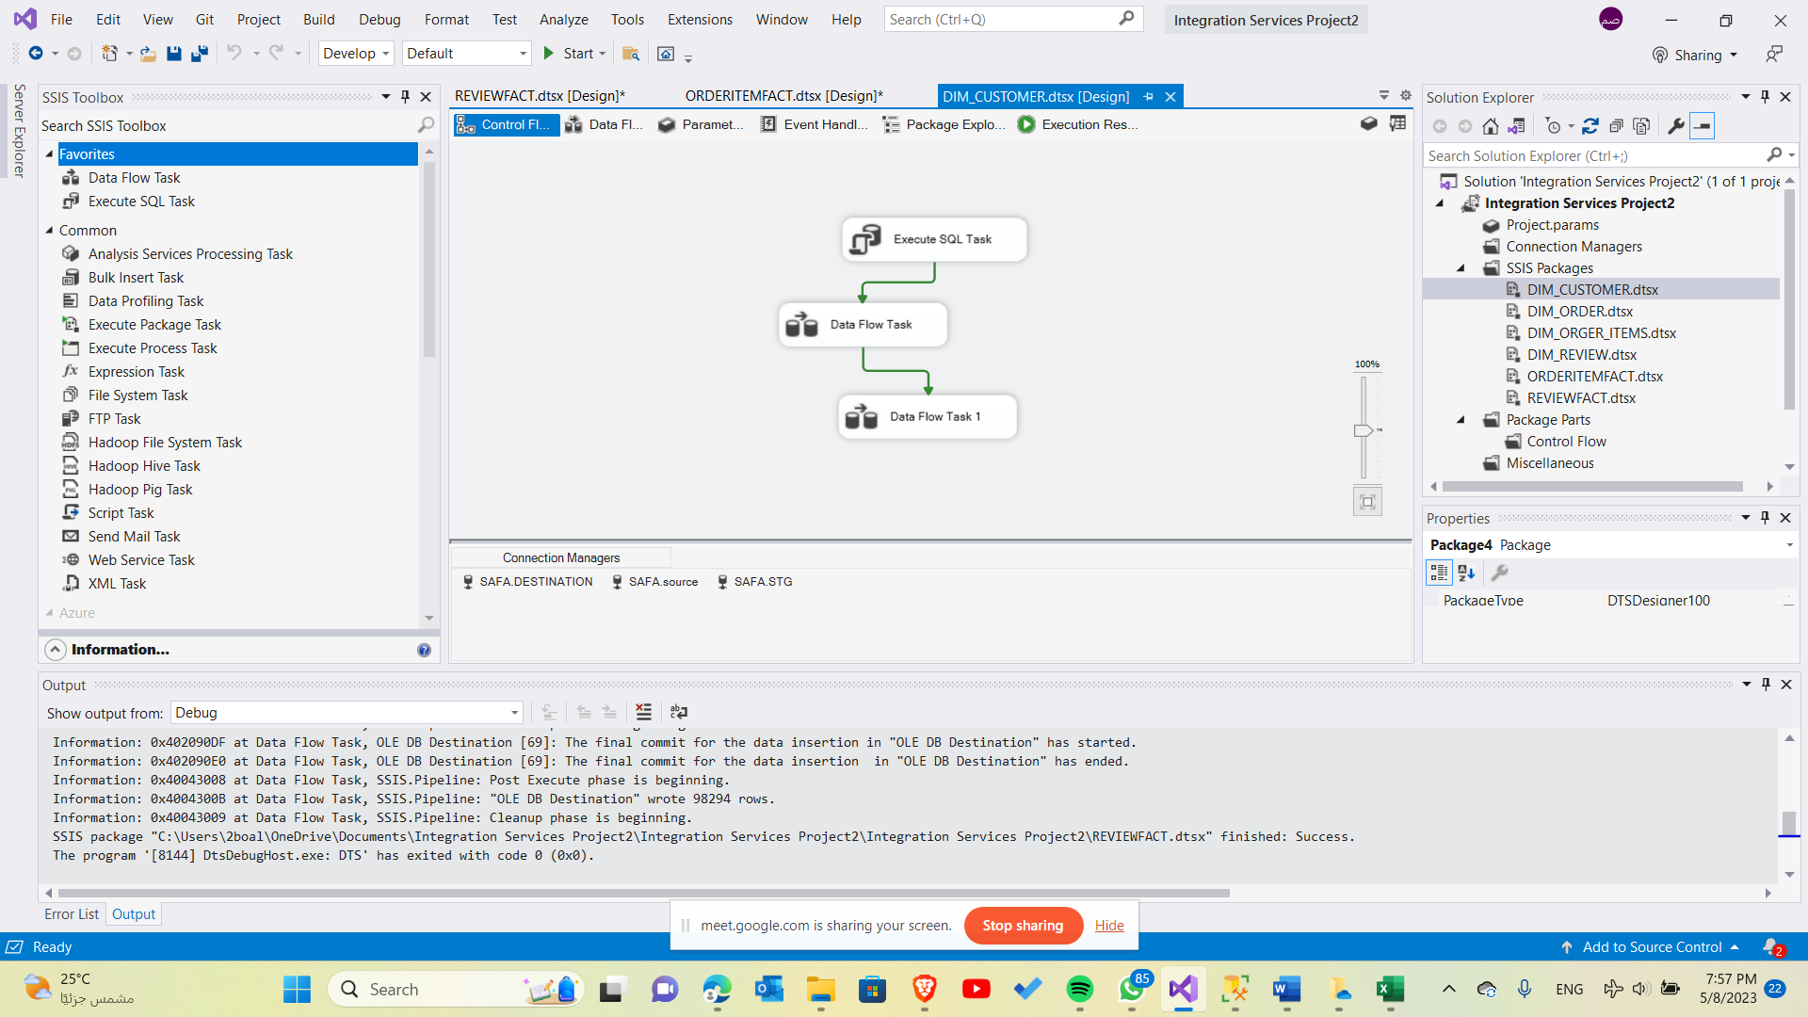

**Customer dim data flow:**

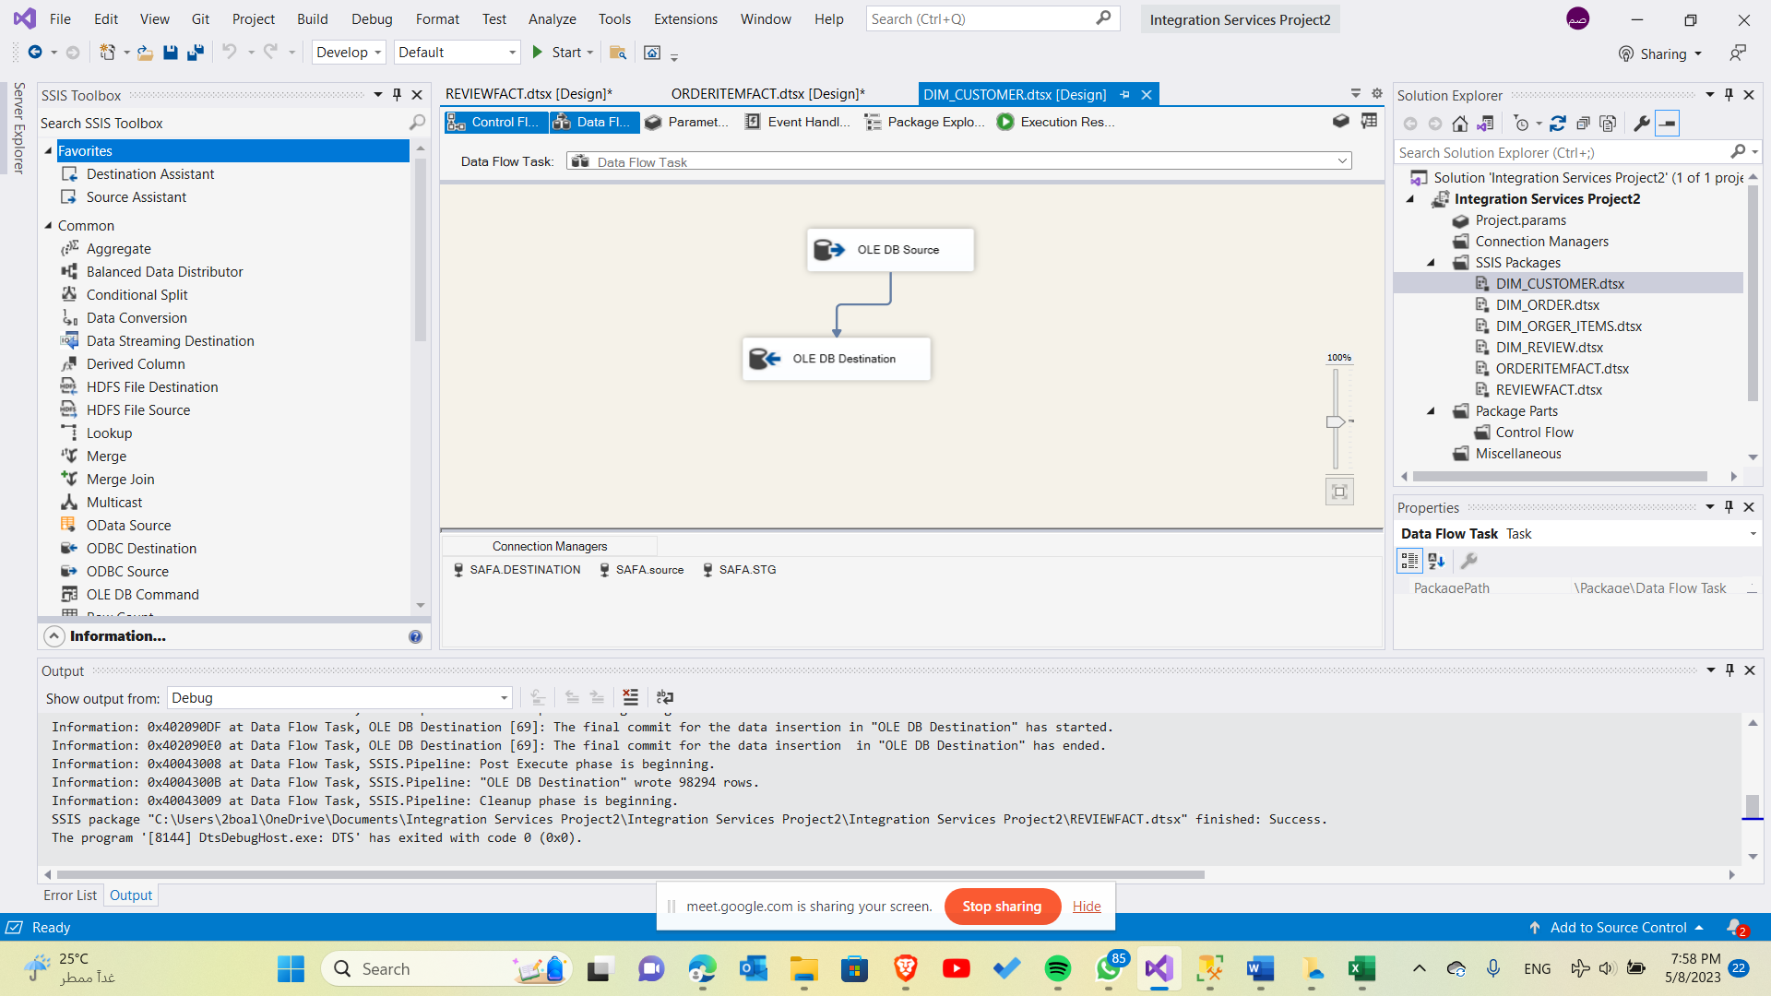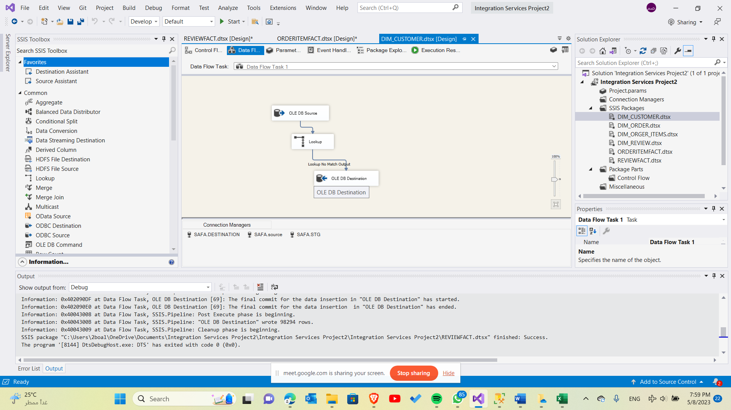

**Order dimension**

**Order dim control flow:**

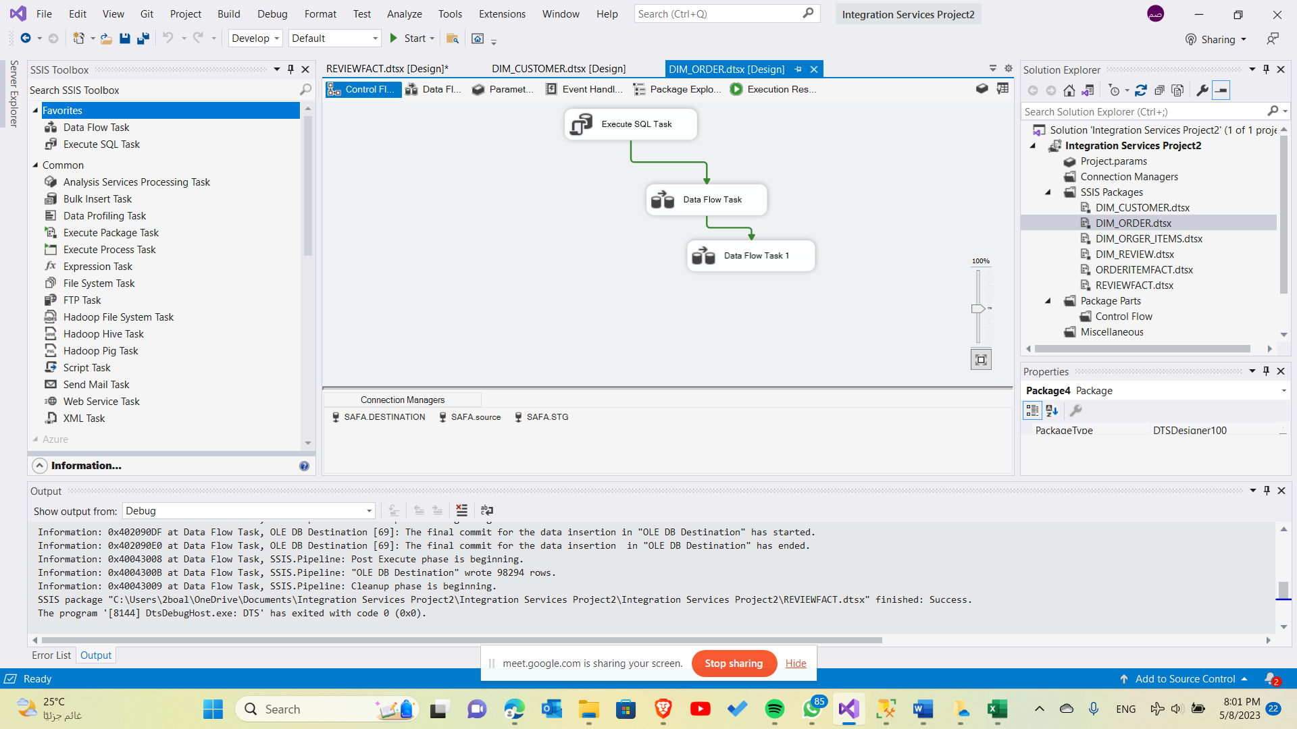

**Order dim data flow:**

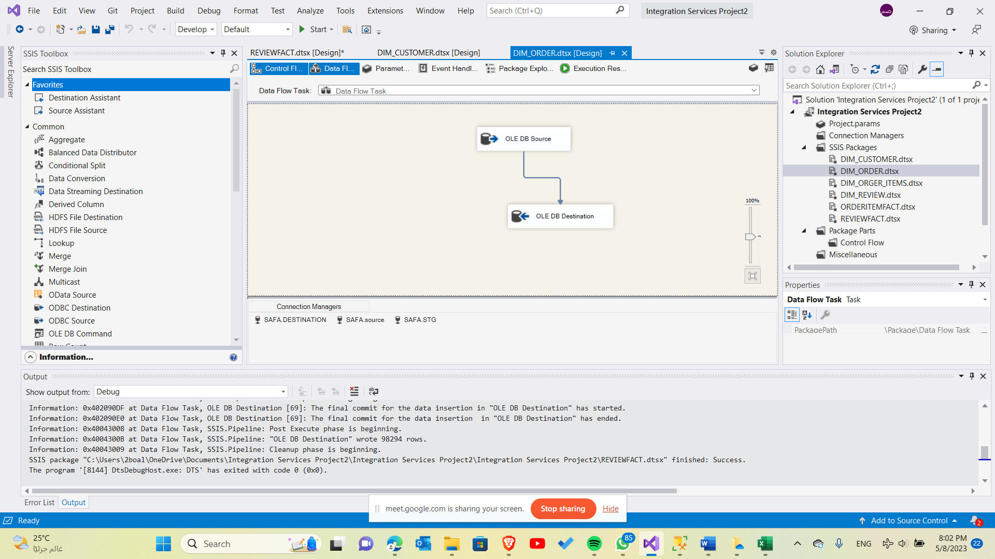 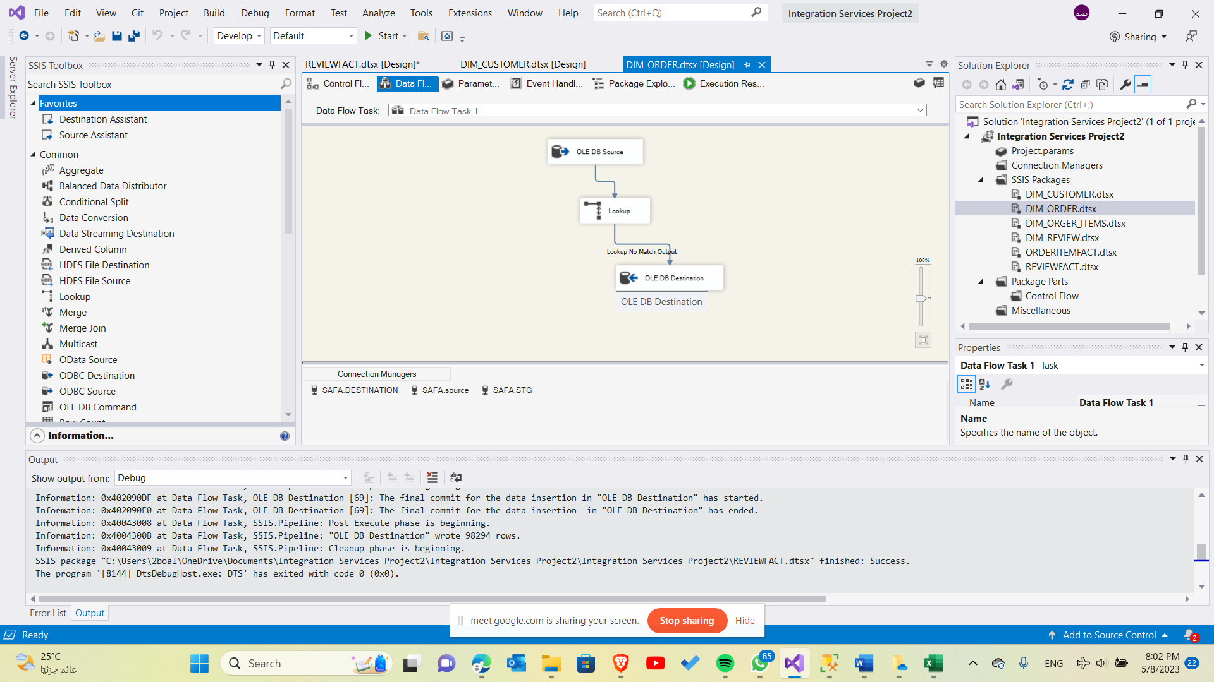

**Review dimension**

**Review dim control flow:**

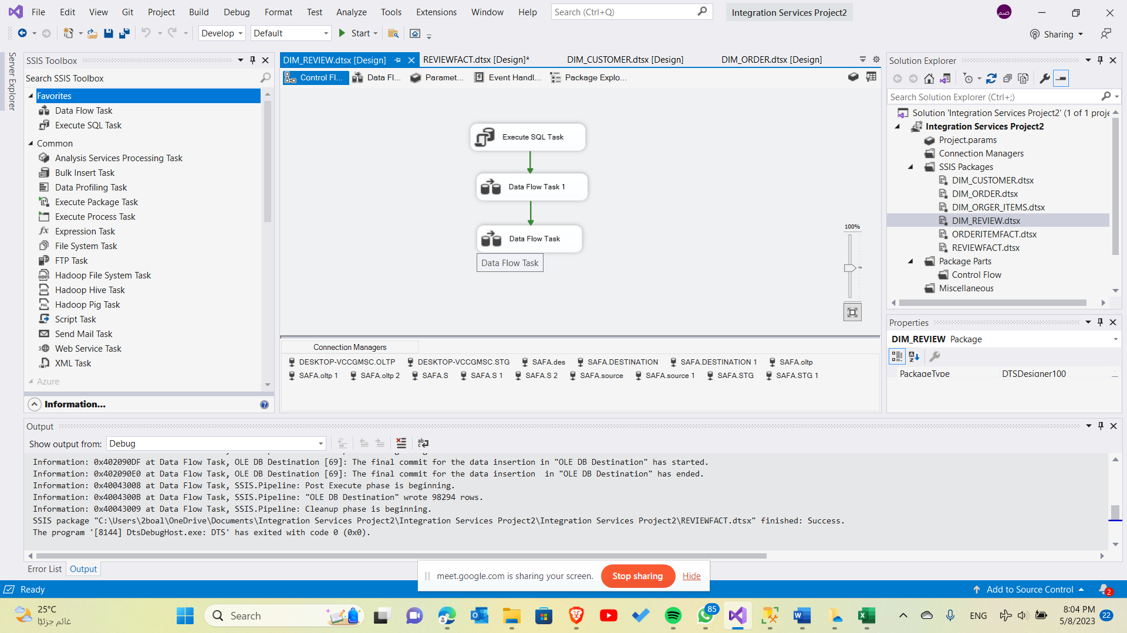

**Review dim data flow:**

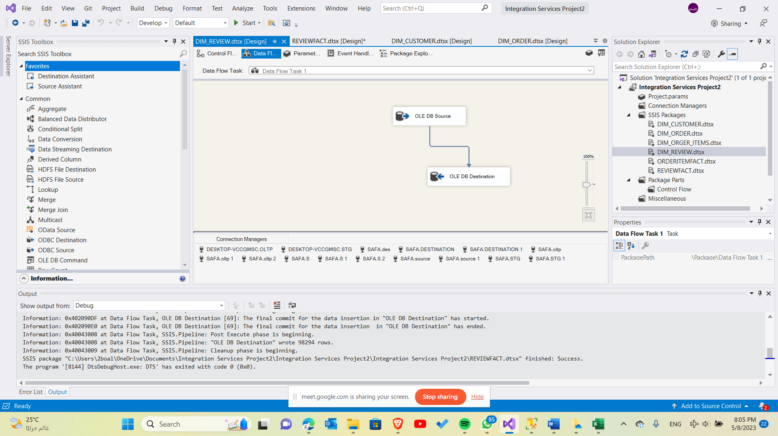

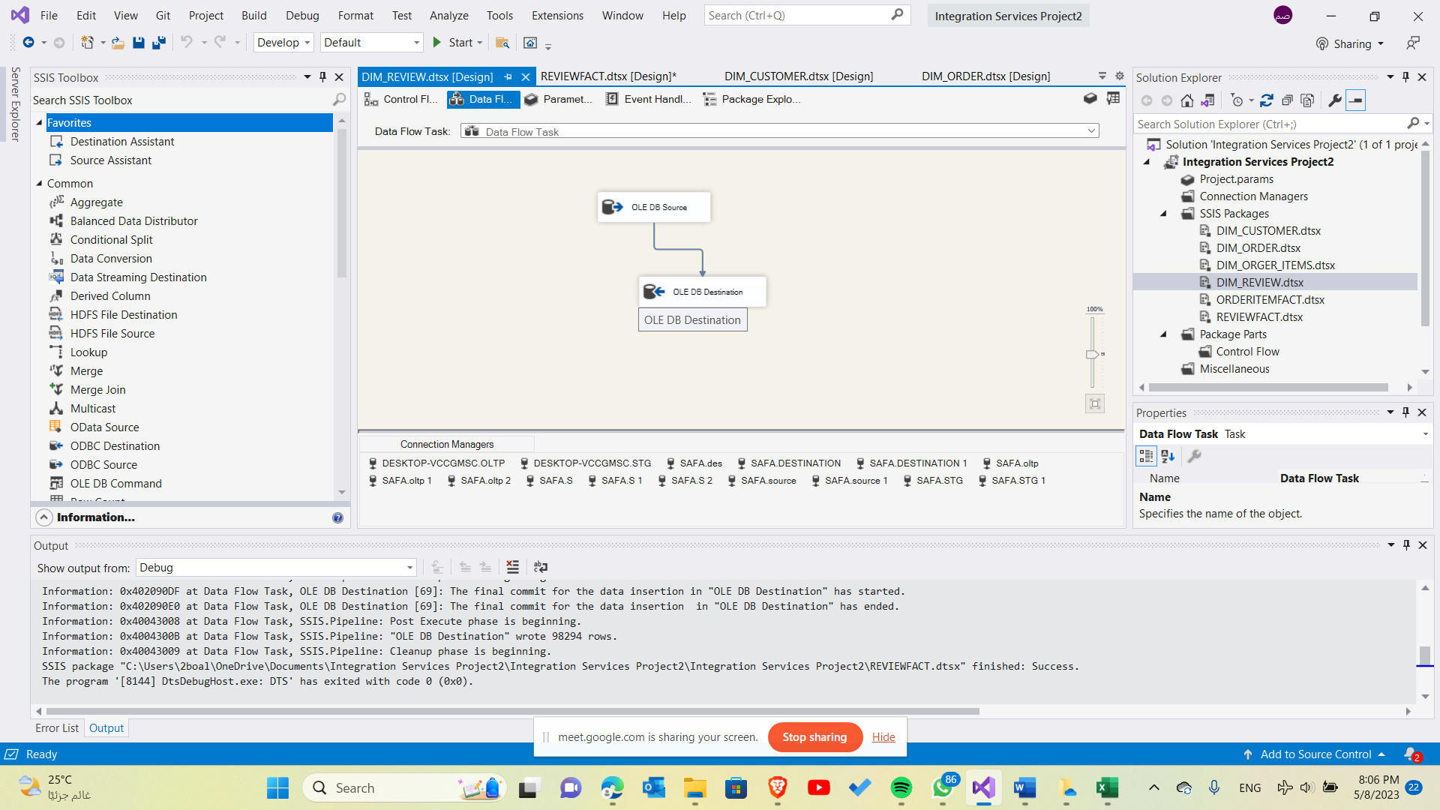

**Order item dimension**

**Order dim control flow:**

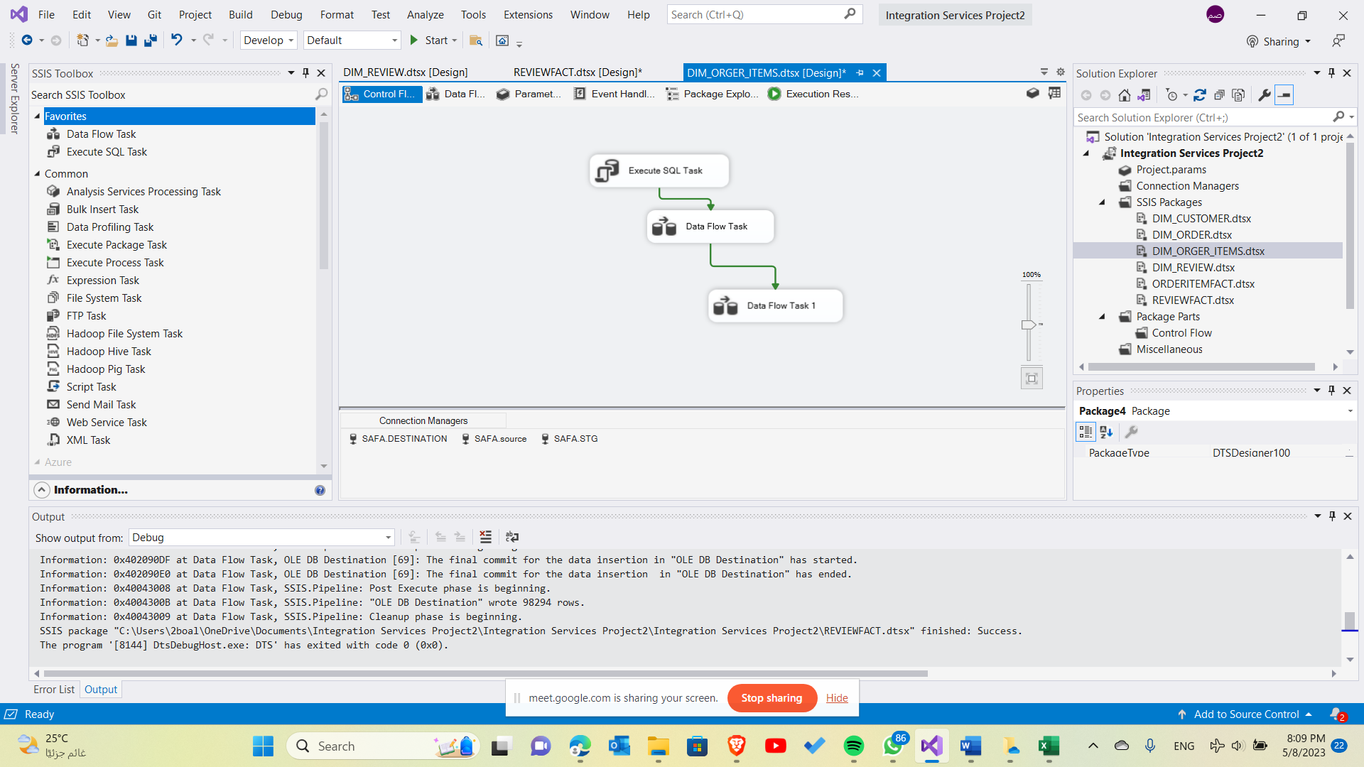

**Order dim data flow:**

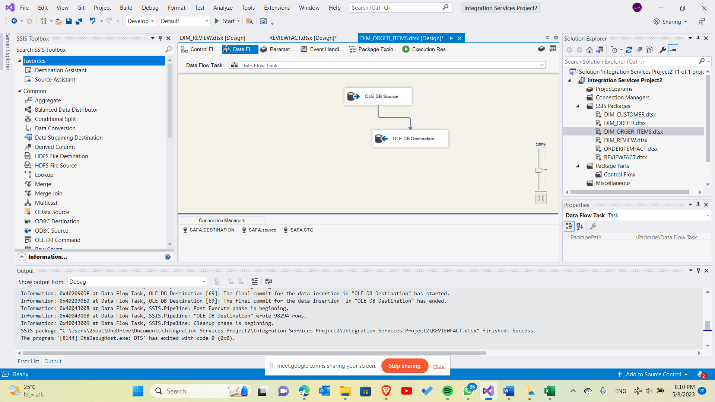 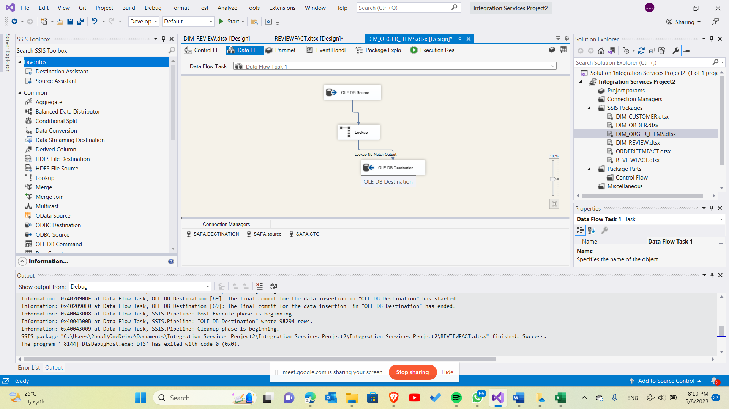

**Product dimension**

**Product dimension control flow:**

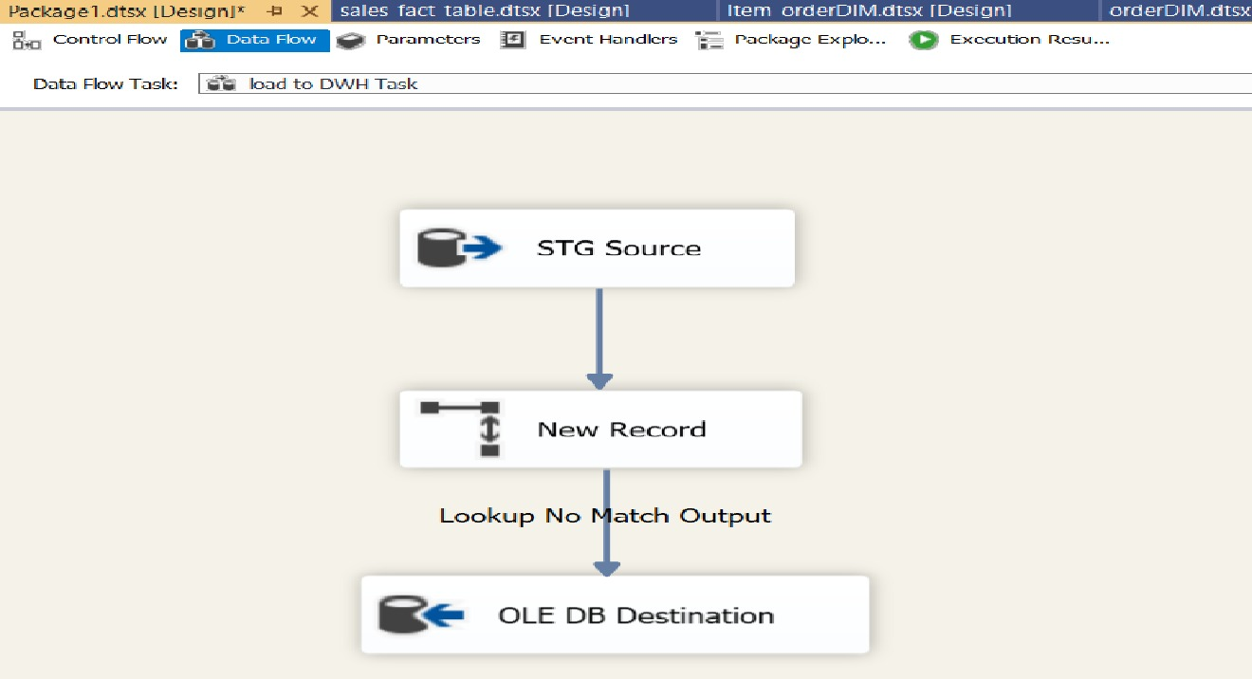

**Product dimension data flow:** 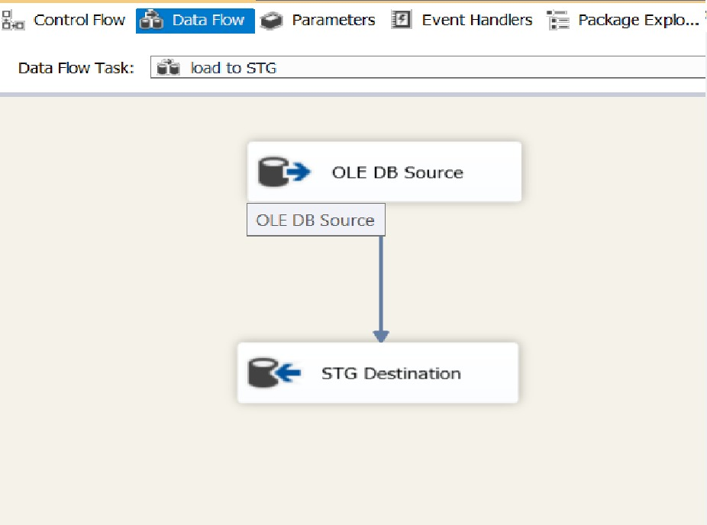

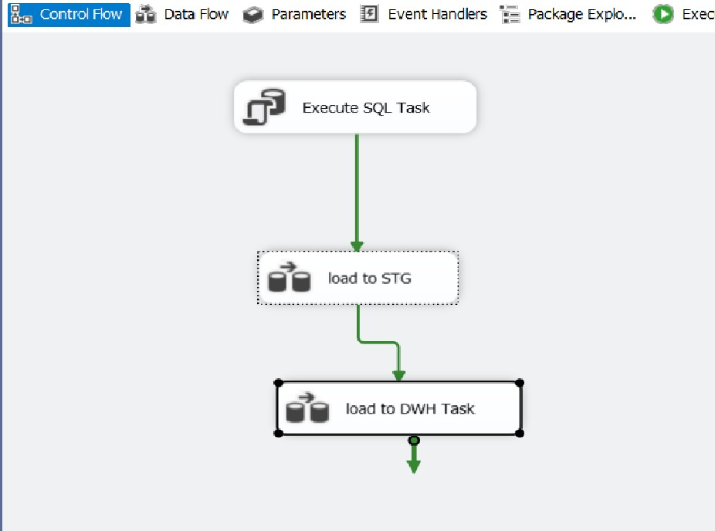

**Dashboard**

